**DAV HZL SR. SEC. SCHOOL, DARIBA**

**TENTATIVE CO-CURRICULAR ACTIVITIES 2024-25**

|  |  |  |
| --- | --- | --- |
| **Date** | **Class** | **Activity (Events)** |
| 06/04/2024 | III TO V | Cinematic Odyssey: Arya Samaj Chronicles |
| VI TO VIII | Narrative Alchemy: Crafting English Tales |
| IX TO XII | Lens Enchantment: Interclass Cinematic Journey |
| 20/04/2024 | III TO V | Soliloquy Symphony: Mastering English Monologues |
| VI TO VIII | Dramatic Flourish: Theatrical Skits in English |
| IX TO XII | Electoral Insights: Interclass PowerPoint Showdown |
| 04/05/2024 | III TO V | Artistry Unleashed: Collage Creation Extravaganza |
| VI TO VIII | Sculpting Stories: From Clay to Chronicle |
| IX TO XI | Pixel Perfection: Design Delights with Photoshop |
| 05/07/2024 | III TO VIII | Green Horizon: Plantation Expedition |
| 06/07/2024 | III TO V | Calligraphy |
| VI TO X | Echoes of Ecology: English Environmental Orations |
| 11/07/2024 | III TO XII | Leadership Unveiled: Investiture Spectacular |
| 20/07/2024 | III TO V | Lexical Showdown: Spellbinding Spell Bee |
| VI TO VII | Verbal Voyage: Vocabulary Ventures |
| IX TO XI | Enlightening Discourse: TED Talk Showdown |
| 03/08/2024 | III TO V | Culinary Chronicles: Fireside Cooking & Artistry |
| VI TO IX | Taste Temptations: Culinary Competition |
| 17/08/2024 | III TO VIII | Cultural Kaleidoscope: Rangoli, Rakhi& Arya Samaj Quizzes |
| 31/08/2024 | III TO V | Social Science Showdown: Quiz Quest |
| VII TO X | Parliamentary Prowess: Youth Debate Showdown |
| 06/09/2024 | III TO V | Hindi Heritage: Crafting Original Stories & Poems |
| VI TO VII | Hindi Heritage: Crafting Original Poems |
| VIII TO X | Declamatory Divinity: Hindi Oratory Odyssey |
| 05/10/2024 | III TO V | Blogosphere Brilliance: Crafting Digital Chronicles |
| VI TO VII | Wall Wonders: Mural Masterpieces |
| VIII | Wonders on earthen plates |
| 19/10/2024 | III TO V | Moral Mosaic: Hindi Skits on Values |
| VI TO IX | Theatrical Tribute: Great Personality Dramatizations |
| 08/11/2024 | III TO V | Melodic Medley: Songster Showdown |
| VI TO IX | Devotional Delights: Bhajan Bliss |
| 23/11/2024` | III TO V | Innovation Illuminated: Inventors' Showcase |
| VI TO VII | Journey of a Dreamer;Biography |
| VIII TO IX Sci. | Scientific Sorcery: Enchanting Science Magic |
| 07/12/2024 | III TO V | Literary Legacy: Bookmark Bonanza |
| VI TO VIII | Informative Imprints: Brochure Brilliance |
| 21/12/2024 | III TO IX | Math Marvels: Exploring Fun & Practical Mathematics |
| 18/01/2025 | III TO VII | Patriotic Penmanship: Slogan Sketching & Doodling |
| 31/01/2025 | III TO V | Resourceful Innovation: Waste Material Wonders & Presentations |

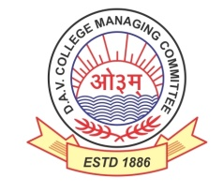

DAV HZL Sr. Sec. School dariba

rajsamand (raj.)

DAV HZL Sr. Sec. School dariba, rajsamand(raj.)

Split-up Syllabus

Class- III

Split-up Syllabus & Activities

for the session

2024-25

Class-X

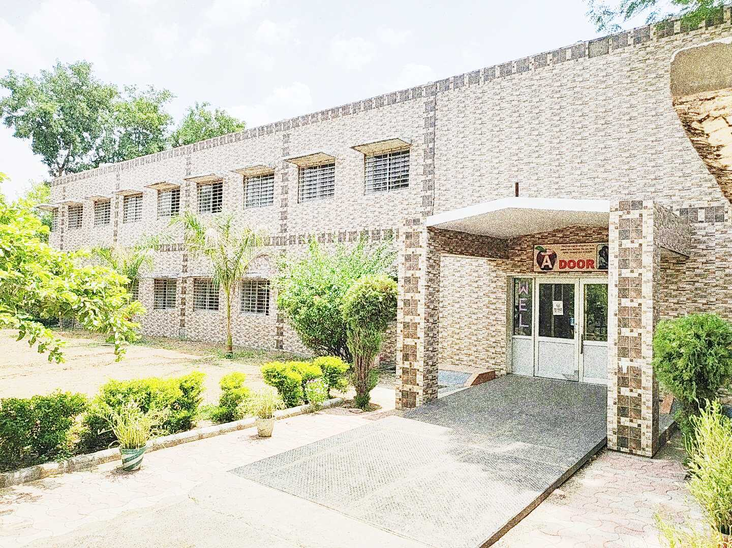

Address : Rajpura-Dariba, Distt. – Rajsamand (Raj.) 313211

Contact : (02952)265130 Email : davhzl_dariba@yahoo.com Website : ttp://www.davhzldariba.in

|  |  |  |  |
| --- | --- | --- | --- |
| **Subject** | | **PT- I** | **PT- II** |
| English | | A Letter to God, Dust of Snow, Tenses, Passage | Nelson Mandela, A Triumph of Surgery, A Tiger in the Zoo, How to Tell Wild Animals, Modals, Letter- Writing, Passage |
| Hindi | | f{kfrt dkO; [kaM ikB & 1 lwjnkl ¼in½  f{kfrt x| [kaM ikB & 7 Lo;a izdk'k ¼usrkth dk p'ek½  vifBr x|ka'k  O;kdj.k & vyadkj]- - अनुप्रास] | f{kfrt dkO; [kaM ikB & 2 rqylhnkl & jke y{e.k & ij'kqjke laokn  x| [kaM ikB & 8 jkeo`{k csuhiqjh cky xksfcu Hkxr  O;kdj.k & vyadkj]- उतपेशा अतिशयोक्ति vifBr dkO;ka'k] |
| Maths | | Chapter – 1 & 2 | Chapter – 3, 4 |
| Sci | Che. | Chemical reactions and Equations | Acids, bases & salts |
| Phy. | Reflection & refraction | Chapter – 11 |
| Bio. | Chapter – 5 | Our Environment |
| S.St. | Eco. | Chapter – 1 | - |
| His. | Chapter – 1 | - |
| Geo. | - | Chapter – 1 |
| Civics | - | Chapter – 1 |
| ICT | | Unit – 3 | Unit – 6 |

|  |  |  |
| --- | --- | --- |
| **Subject** | | **Mid Term** |
| English | | Prose- A letter to God, Nelson Mandela - Long Walk to Freedom, Two Stories About Flying From the Diary of Anne Frank, Glimpses of India  A Triumph of Surgery, The Thief's Story, The Midnight Visitor, A Question of Trust, Footprints Without Feet,  Poem- Dust of Snow, Fire and Ice, A Tiger in the Zoo, How to Tell Wild Animals, The Ball Poem,  Formal Letter, (Aanalytical Paragraph) , Grammar- Tenses, Modals, Passage |
| Hindi | | dkO; [kaM ikB & 1,2,3 ¼ikB lwjnkl in ikB 2 jke y{e.k &ij'kqjke laokn पाठ -3 आत्मकथ्य ½  x| [kaM ikB & 7 8 9 ¼ ikB usrkth dk p'ek ikB 8 cky xksfcu Hkxr लखनवी अंदाज ½  कृतिका पाठ -1 माता का आँचल  व्याकरण – वाच्य , पद परिचय , अलंकार , रचना के अनुसार वाक्य भेद लेखन खंड - औपचारिक ओर अनौपचारिक पत्र अनुच्छेद ई-मेल संवाद , विज्ञापन , संदेश  vifBr x|ka'k , अपठित काव्यांश |
| Maths | | Chapter – 1, 2, 3, 4, 5, 7, 10, 11, 14 |
| Sci. | Che. | Chemical reactions and Equations , Acids, bases & salts |
| Phy. | Chapter – 10, 11 |
| Bio. | Chapter- 5,6,15 |
| S. St. | Eco. | Chapter – 1, 2 |
| His. | Chapter – 1, 2 & 3 |
| Geo. | Chapter – 1, 2 |
| Civics | Chapter – 1, 2 |
| ICT | | Unit – 1, 2, 3, 6, 7 |

|  |  |  |
| --- | --- | --- |
| **Subject** | | **Final Term** |
| English | | Complete Course (As per updated syllabus) |
| Hindi | | lEiw.kZ ikB~;Øe सी. बी. एस. ई. नियमानुसार |
| Maths | | Chapter – 1 to 14 |
| Sci. | Che. | Complete Course (As per updated syllabus) |
| Phy. | Complete Course (As per updated syllabus) |
| Bio. | Complete Course (As per updated syllabus) |
| S. St. | | Complete Course (As per updated syllabus) |
| ICT. | | Complete Course (As per updated syllabus) |

|  |  |
| --- | --- |
| **Exam** | **TENTATIVE DATES OF EXAM** |
| **PT – I** | First Week of May 2024 |
| **PT- II** | First Week of August 2024 |
| **MID – TERM** | Third Week of September 2024 |
| **Pre-Board-I** | Second Week Of December 2024 |
| **Pre-Board -II** | January 2025 |
| **FINAL TERM** | As per CBSE |